ANNEX 11
Guideline on PhilGEPS
How to Generate PhilGEPS Posting Report
- Log on to pbb.philgeps.gov.ph
- Type-in Assigned GEPS Userid
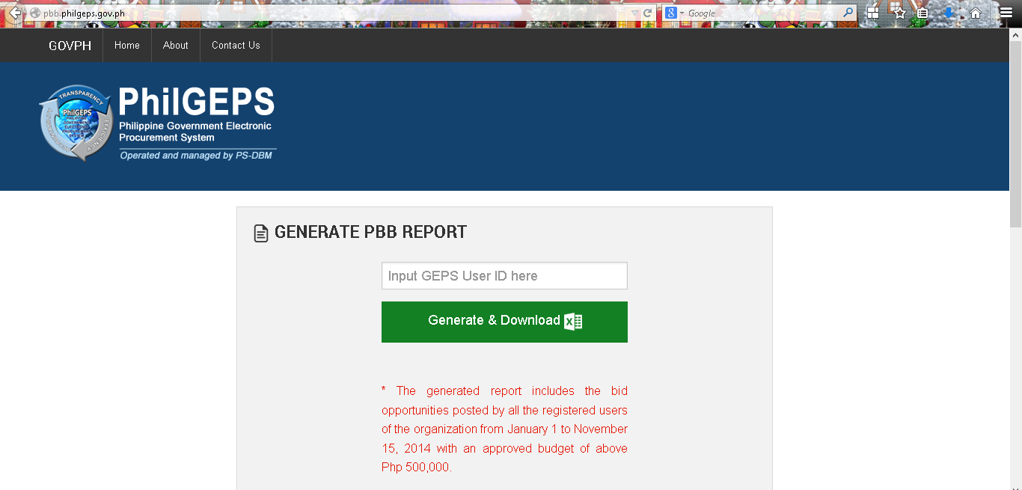

- Click Generate& Download button
- Save the file (or Click Ctrl+J to open the Downloads folder).
- For agencies with no posted bid opportunities with an ABC of above Php 500,000, download and accomplish the Certificate of No PhilGEPS Postings
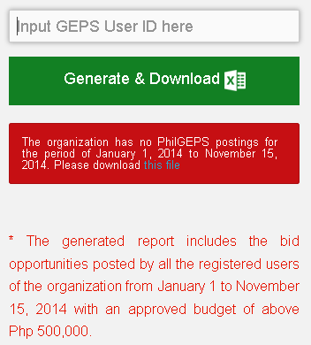

How to Accomplish the Certificate of Compliance on PhilGEPS Postings
- Using the generated report,identify the notices with “Awarded/Partially Awarded” status without Date of Posting of P.O. / Approved Contract and Notice to Proceed.
# | Ref. No | Date of Posting of Invitation to BID/REI | Bid Notice Title | Date of Posting of Notice of Award | Date of Posting of P.O. / Approved Contract and Notice to Proceed | Bid Notice Status | Created By | Remarks*
7 | 123456 | Apr 11, 2014 | Procurement of Sports Supplies, Materials and Equipment for 2014. | May 16, 2014 |  | Partially Awarded | userid
8 | 123457 | Apr 16, 2014 | Delivery of Test Materials and Other Documents | Jun 17, 2014 |  | Awarded | userid
- If the notices have Approved Contract/Purchase Order (AC/PO) and Notice to Proceed (NTP), post the Notice to Proceed in PhilGEPS. Indicate “NTP posted in PhilGEPS” and the award notice number in the Remarks column.
- Otherwise,provide the procurement activity stage that is currently observed (i.e. “Document for Signature”) in the Remarks column.

2. Identify the notices with “Closed” status.
9 | 123458 | Sep26, 2014 | Delivery of Test Materials and Other Documents |  |  | Closed | userid
- If the notices are declared either failed or cancelled, post the result in PhilGEPS and indicate “Bid Failure or Cancellation Posted in PhilGEPS” in the Remarks column.
- If the notices are awarded with Approved Contract/Purchase Order (AC/PO) and Notice to Proceed (NTP), post the Award Notice and Notice to Proceed in PhilGEPS. Indicate “Award Notice and NTP posted in PhilGEPS” and the award notice number in the Remarks column.
- If the notices are awarded but the Approved Contract/Purchase Order (AC/PO) and Notice to Proceed (NTP) are not yet available, post the Award Notice in PhilGEPS. Indicate “Award Notice posted in PhilGEPS”, the award notice number and the current status of the NTP (i.e. “AC/PO/NTP for signature”) in the Remarks column.
- If the noticeshave no results yet (such as failed, cancelled, awarded), provide the procurement activity stage that is currently observed (i.e. “On-going evaluation/post-qualification”, “Documents for signature”, “With pending RR/Protest”) in the Remarks column.

3. Identify the notices with “Active” status.
10 | 123459 | Oct 16, 2014 | Supply of Services for the Comprehensive Maintenance and Support Services for IT Infrastructure of Agency Central Office |  |  | Active | userid
  - If the closing date for the notices in the generated report has lapsed, follow the procedures in step 2.
  - Otherwise, provide the procurement activity stage that is currently observed (i.e. “-On-going”) in the Remarks column.
Notes:
- Notices with Failed, Cancelled and Shortlisted statuses as indicated in the system generated report are considered complete.
- For “cancelled accounts”, send reactivation request to agency@philgeps.gov.ph
- Accomplished/Completed PhilGEPS CoC’s should be send to pbb@philgeps.gov.ph

Certification of Compliance with PhilGEPS Template
(Agency’s Letterhead)

CERTIFICATION OF COMPLIANCE
PhilGEPS Posting
This is certify that the(name of agency), for the period beginning November 16, 2014up to November 15, 2015, has posted the Invitation to Bid/Request for Expression of Interest (REI), Notice to Proceed and the approved / awarded contract for all the projects listed below at the Philippines Government Electronic Procurement System (PhilGEPS), to wit:
Reference Number | Date of Posting of Invitation to Bid / REI | Project | Date of Posting of the Notice of Award | Date of Posting of the Approved Contact | Date of Posting of the Notice to Proceed

This is tofurther certify that the list includes of all projects procured by the (name of agency)as of (date).
This certification is being issued to attest to the truth and accuracy of all foregoing based on available records and information that can be verified with the PhilGEPS; and with the Annual Procurement Plan(APP) posted under the Transparency Seal of the said agency.

IN WITNESS WHEREOF, we have hereunto affixed our signatures on the ____ day of _____ 2015 at (City/Municipality), Philippines.

Chairman, BAC Head, Procurement Office

()

